Hello!

Please follow these instructions to add the attached .blg files to your Payload Kit Simulation Software:

* Lunar_G_Trajectory.blg
* Lunar_G_Trajectory_Start_T_Minus_25_Seconds.blg

1. Open Payload Kit and navigate to the Simulator Tab. Find the Manage Profiles button and click here:

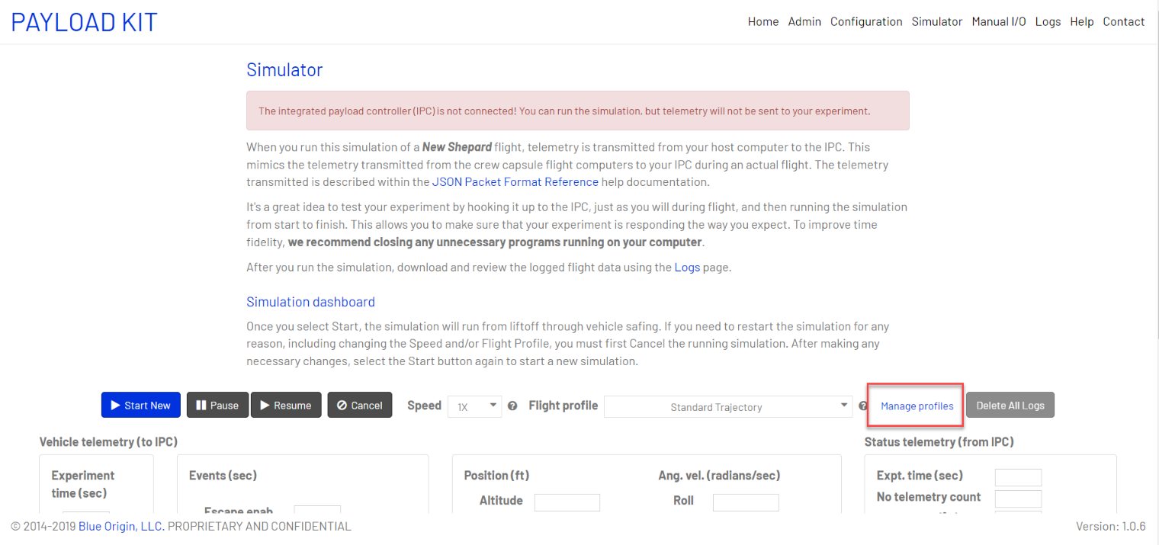

1. You will then want to hit the Choose button shown below, and navigate to where the .blg files are saved on your machine.

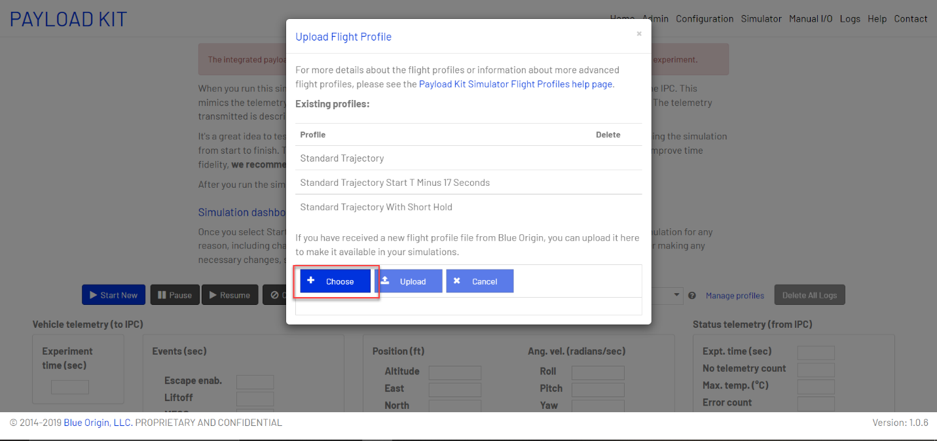

1. After selecting the file, hit the Upload button.

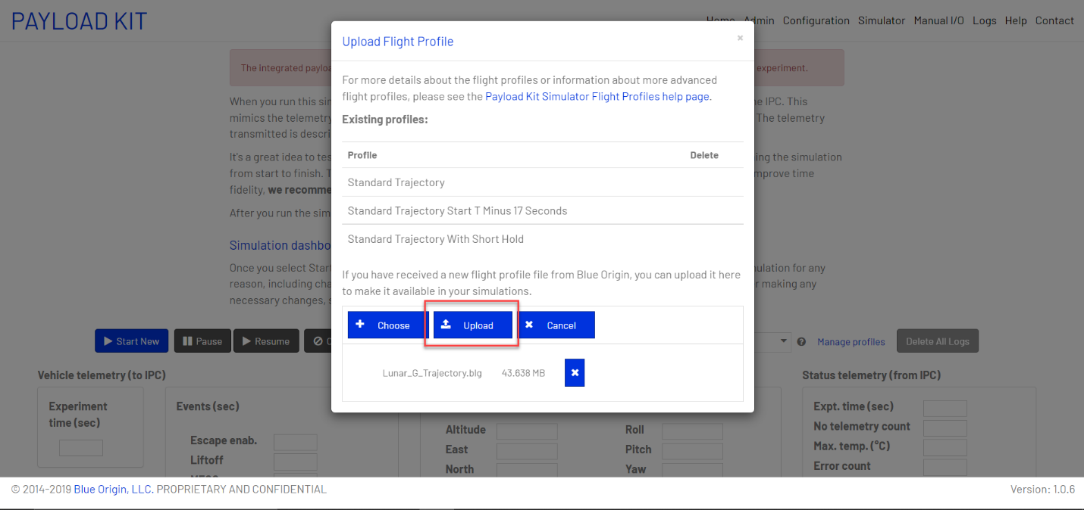

1. You should see a note that the File has uploaded successfully!

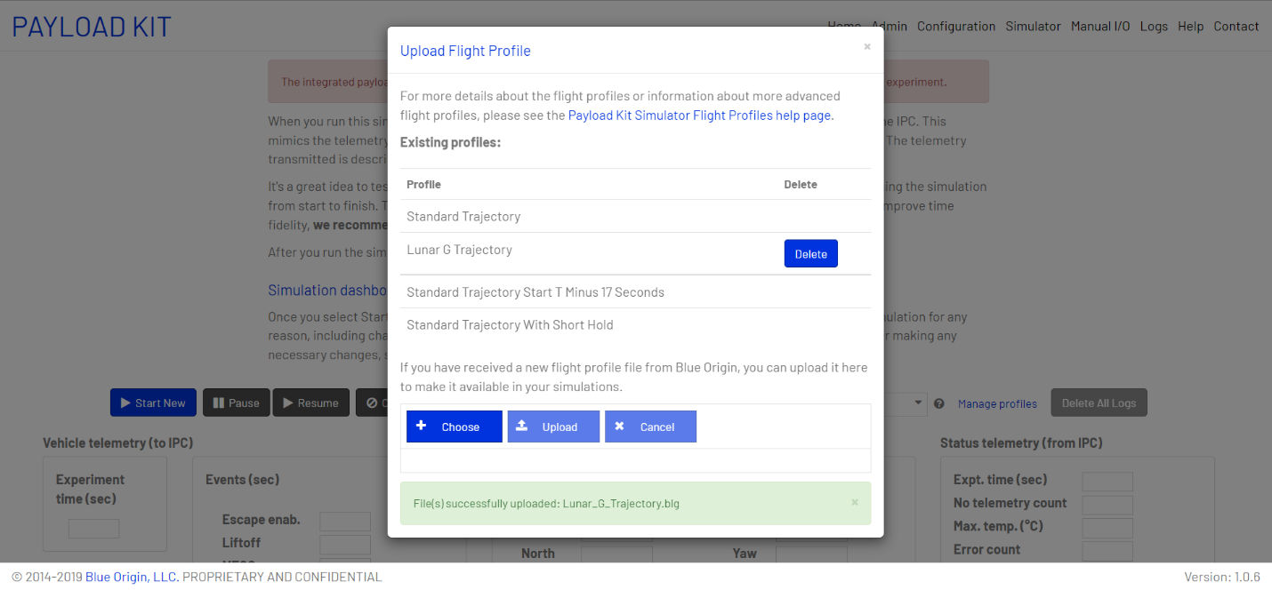

1. Now that you have uploaded the file, it should show up on the trajectory list.

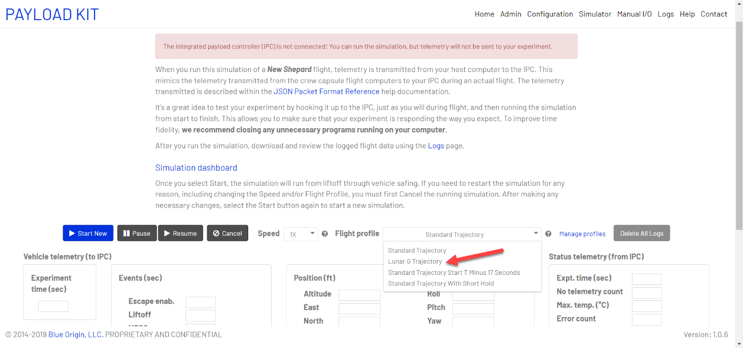

If you have any trouble please reach out to your Payload Integration Manager or [payloadsupport@blueorigin.com](mailto:payloadsupport@blueorigin.com).